

Practices for Secure Software Report

Table of Contents
Practices for Secure Software Report 1
Document Revision History 3
Client 3
Developer 3
1. Algorithm Cipher 3
2. Certificate Generation 3
3. Deploy Cipher 4
4. Secure Communications 5
5. Secondary Testing 5
6. Functional Testing 5
7. Summary 6
8. Industry Standard Best Practices 6

Document Revision History

Version | Date | Author | Comments
1.0 | 12 DEC 2025 | Matthew Willhite

Client



Developer
Matthew Willhite

Algorithm Cipher

For this project, I chose AES-256 because it is a strong and reliable encryption method that many organizations still use today. AES-256 is a symmetric cipher that protects data using a 256-bit key, which makes it extremely difficult to break through brute-force attacks. When used in GCM mode (AES-GCM), it also provides integrity checks, so the system can tell if any encrypted data was changed while it was being sent.

The project also uses SHA-256 as its hash function. SHA-256 creates a 256-bit hash value from any input and is one-way, meaning the original data cannot be recovered from the hash. Even small changes in the input create a completely different hash, which makes SHA-256 useful for verifying data integrity.

Both AES-256 and SHA-256 depend on strong keys and random values. AES uses a symmetric key for speed, and secure implementations use random initialization vectors so that repeated encryption does not create patterns. HTTPS handles the asymmetric side of things by using public and private keys to set up a secure connection before the symmetric key is used.

Encryption algorithms have evolved over time as older methods became easier to attack. DES and SHA-1 were once common, but improvements in computing power made them weak. AES and SHA-256 were designed to replace them and are now standards because they are still considered secure today. That history and reliability are why AES-256 and SHA-256 are appropriate choices for Artemis Financial’s application.

Certificate Generation

To enable HTTPS for the application, I created a self-signed certificate using the Java Keytool in Eclipse. I generated a new keystore, created a key pair, and filled out the required information like my name and organization. After that, I exported the public certificate as a .cer file so the application could use it during HTTPS setup. Including the .cer file helps prove the certificate was created correctly and is ready for the server to use.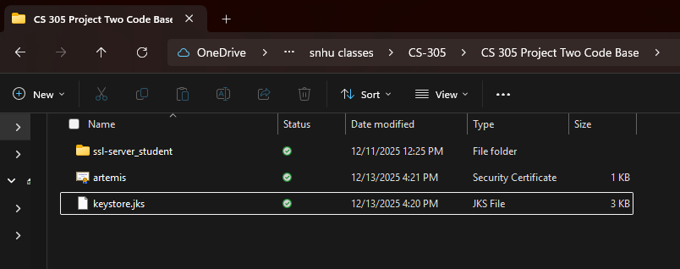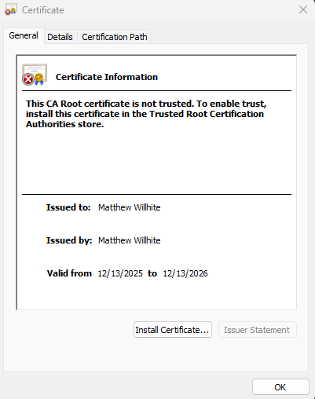

Deploy Cipher

After setting up the certificate, I refactored the code so the /hash endpoint could use SHA-256 to create a checksum. When a user enters data, the application calculates the SHA-256 hash and displays it along with my name. This shows the hashing function works correctly. I tested it by running the application and checking the output in the browser using a unique data string.

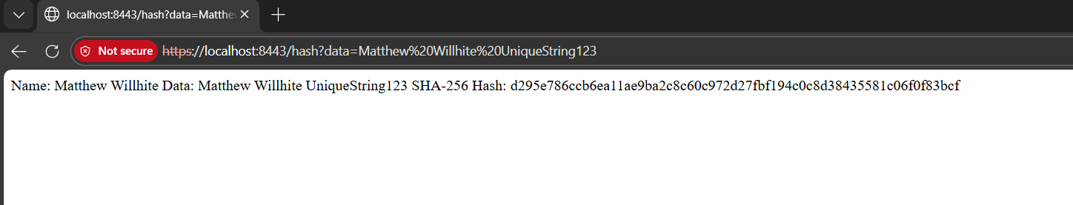

Secure Communications

Next, I updated the application’s properties file to run over HTTPS instead of HTTP. I added the SSL settings, pointed the server to my keystore, and changed the port to 8443. After running the application, I went to https://localhost:8443/hash?data=Matthew%20Willhite%20UniqueString123 in a browser. Even though the browser showed a warning because the certificate is self-signed, the page still loaded after approval, which confirmed that HTTPS was working and the connection was encrypted.

Secondary Testing

I ran a second dependency check to make sure the changes I made did not introduce new security vulnerabilities. The scan completed successfully, and the application still ran without errors. Some existing vulnerabilities came from older libraries in the starter code, but none of them were caused by anything I added. I included screenshots of both the successful run and the dependency-check report in the submission.

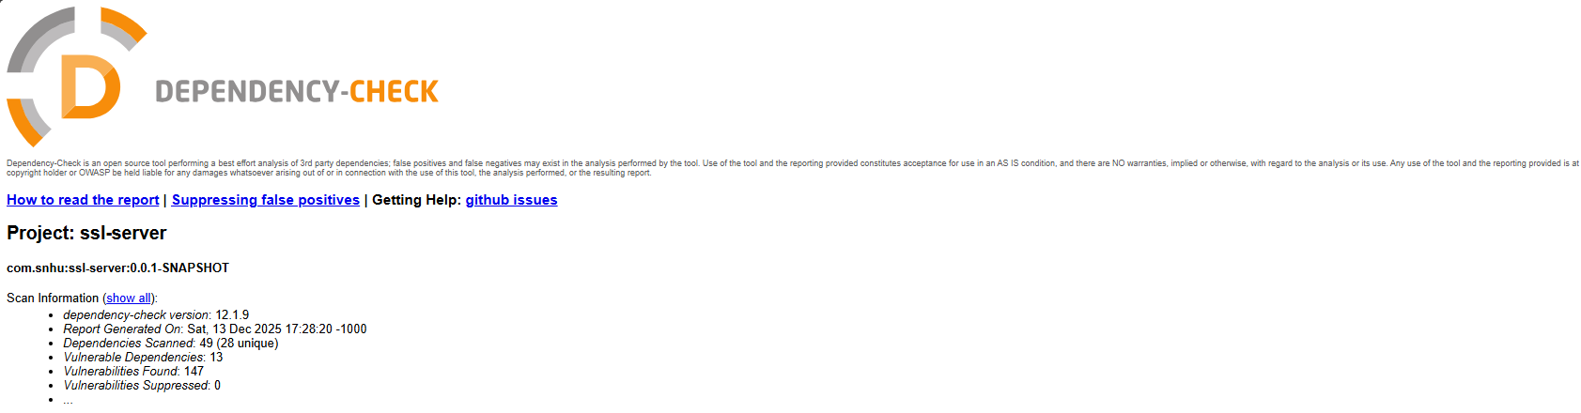
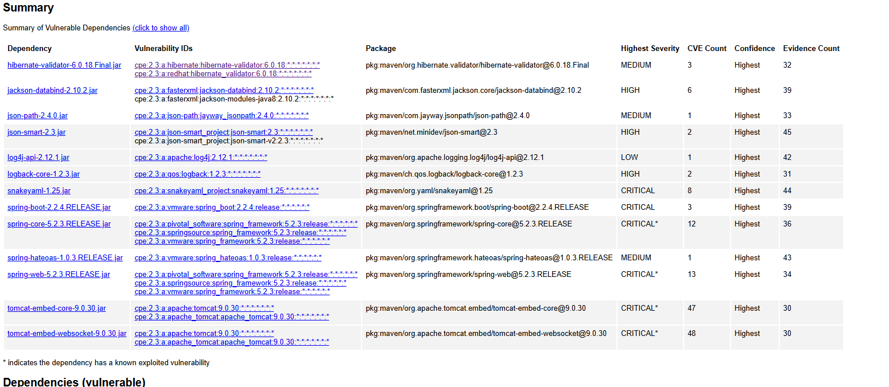

Functional Testing

I manually reviewed the refactored code and then ran the application to check that everything worked as expected. The code compiled with no syntax errors, and when I tested the /hash endpoint, it returned the correct SHA-256 hash along with my unique string. This showed that the refactored code was working correctly and didn’t break any part of the application.

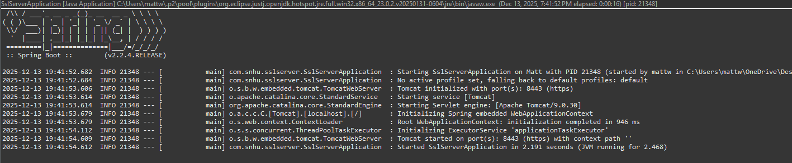

Summary

Overall, the refactoring work added important security features to the application. I added SHA-256 hashing, enabled HTTPS, and verified that everything worked through testing and dependency scanning. These changes strengthened the application by protecting data and making sure communication between the client and server is secure. Following the steps of the vulnerability assessment process helped me identify what needed to be improved and then verify that the fixes did not create new issues.

Industry Standard Best Practices

During this project, I used best standard security practices like choosing strong algorithms (AES-256 and SHA-256), enabling HTTPS, and scanning the project for vulnerabilities. Using these practices helps keep the application safe over time and reduces the risk of data exposure. For a financial company like Artemis Financial, following secure coding standards is important because it protects sensitive client information and helps maintain trust and reliability across the system.

